# Request for Proposals: BME 580.670-671 “Precision Care Design Studio”

## Template:

**Project Title: Prediction of hypoxemia as an indicator of patient decline**

**Problem Statement**: In one paragraph describe the clinical problem which you propose to address with this project. Specific reference should be made to how data will be used to develop the project solution.

Hypoxemia in critical care patients is both frequent and independently associated with higher mortality. In a recent multi-center study1, over 50% of ICU patients experienced hypoxemia and had double the length of stay versus non-hypoxemic patients. Hypoxemia was found to be frequent among non-ventilated patients and was independently associated with higher mortality (see the related analysis in the embedded figure). As a non-specific indicator of respiratory and, often, cardiovascular decline, hypoxemia frequently precedes diagnosis of other deleterious conditions including pneumonia, acute respiratory distress syndrome, sepsis and cardiac arrest. Despite the ubiquitous observation of the condition, few studies have been reported which provide predictive information in support prophylactic intervention and no approved medical device or software system predicts the future occurrence of hypoxemia. We hypothesize that commonly recorded time series data (in combination with contextual variables) can be used to predict the probability of future sustained hypoxemia and thereby enable intervention prior to the acute and potentially harmful condition. Further, this predictive indicator with other contextual measurements may provide more specific information regarding the nature of patient decline.

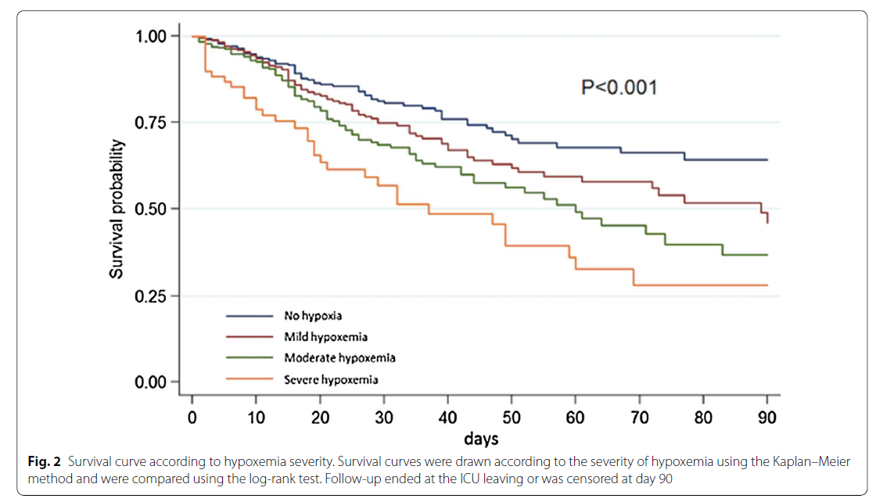

Reproduced from SRLF Trial Group. "Hypoxemia in the ICU: prevalence, treatment, and outcome." Annals of intensive care 8, no. 1 (2018): 82.

**Project Team:** Identify key personnel and their roles (eg. Mentor, co-Investigator, research associate, etc.)

1) Tim Ruchti, PhD (Mentor) -. Dr. Ruchti is an algorithm expert with experience in medical device development. He is currently the Director of Algorithms for Nihon Kohden’s U.S. R&D group and is leading the effort to add data driven clinical applications to Nihon Kohden’s cloud based data platform. He will utilize his background and NK’s internal resources to support the project team.

2)

**Background**: Describe the current state of research and practice as it relates to the proposal. Estimates of the impact of a successful project will be helpful. (No more than 1 page).

Until recently, the prevalence of hypoxemia and related outcomes in the critical care setting had not been formally studied. The recent investigation reported by SRLF Trial Group1 found that of 1604 participating patients (from multiple hospitals and countries), 859 were hypoxemic (51% with mild, 40% moderate and 9% severe hypoxemia). The research team determined that within the observed population hypoxemia is independently associated with mortality and frequent even among non-ventilated patients.

Prediction of hypoxemia is implicitly performed by anesthesiologists during procedures to varying degrees of success based upon their experience and medical knowledge. This motivated a research team from the University of Washington to develop a hypoxemia prediction system called “Prescience” which utilizes commonly collected vital signs and ventilator variables as well as derived features to predict hypoxemia during surgical procedures via machine learning derived models2. The work is distinguished by a novel method to provide clinical insight and interpretation about the basis of the predictions3 in a manner that is independent of model complexity and form.

Further efforts by the same team demonstrated that time series SpO2 measurements (alone) could be used to develop a predictive model for hypoxemia that outperformed anesthesiologists4.

The research presented by Carrara5 examined mortality prediction among MIMC II6 data set patients with septic shock. Using unsupervised clustering, the team found a natural organization of patients into four clusters, one of which was distinguished by the prevalence of hypoxemia.

Outside of these efforts, hypoxemia is used as an indicator and contributes to early warning scores and diagnoses. In this context, the patient has already experienced decline and reactive intervention is warranted.

The frequency of hypoxemia, the correlation to mortality and the body of medical knowledge concerning the destructive nature of the condition (in combination with underlying mechanisms) provides the motivation for applying predictive models outside of surgical procedures. The reported research that is limited to surgical procedures provides a basis for the feasibility of hypoxemia predictions using frequently observed vital signs.

**Potential Solution:** Describe your vision of the result of the student team’s work.

In this project we propose the development of a new clinical prediction system for indicating the probability of future hypoxemia. The target population for this project will be ICU patients with data represented in the MIMIC III database or related sources identified by JHU.

We envision that frequently measured vital signs in combination with inputs, labs and patient demographics will enable the development of models capable of distinguishing patients likely to experience hypoxemia over subsequent time periods. Further, analysis of the patient populations that are successfully predicted may naturally cluster into groups indicative of the underlying mechanism or cause which produced the hypoxemic state.

By working closely with clinical partners, we further anticipate novel information display and work flows to integrate predictive information and insight3 in a manner that supports patient treatment and better outcomes.

Ultimately, our goal is to deploy the developed software system within a hospital information system or data platform that integrates necessary patient variables. The deployment solution will calculate hypoxemia risk scores and related information in near real-time and delivery the results to the clinician in a timely manner and in a way that supports their use cases.

**Preliminary Data/Relevant Experience**: Include any preliminary data that you may already have that relates to the proposal. Please indicate if you have specific experience or education that enhances your ability as a project mentor.

The application idea was developed by reviewing frequently occurring MIMIC III ICD9 codes with clinical teams and Dr. Rai Winslow to identify high value frequently occurring conditions.

**Data Set Identification**: Indicate the data sets or a brief synopsis of elements that you believe will be needed to develop the proposed project. Examples could include physiologic data from OR and ICU monitors, narrative elements from Epic, data from hospital finance systems, etc.

Within the MIMIC III data set, hypoxemia was diagnosed as indicated by ICD9 codes 2165 times in 2081 unique patients. There are likely many more instances of hypoxemia that can be determined on the basis of a standard definition via inspection of routinely measured vital signs.

The data set must further be analyzed to identify data collected outside of surgical procedures as well as the integration of information related to interventions (i.e., patients receiving oxygen, ventilated, etc.).

**Other Supporting Information**: Please include letters from co-investigators or other information that you believe support your application.

**References:** Please include no more than 10 references that support your proposal.

1. SRLF Trial Group. "Hypoxemia in the ICU: prevalence, treatment, and outcome." *Annals of intensive care* 8, no. 1 (2018): 82.
2. Lundberg, Scott M., Bala Nair, Monica S. Vavilala, Mayumi Horibe, Michael J. Eisses, Trevor Adams, David E. Liston et al. "Explainable machine-learning predictions for the prevention of hypoxaemia during surgery." *Nature biomedical engineering*, no. 10 (2018): 749.
3. Lundberg, Scott M., and Su-In Lee. "A unified approach to interpreting model predictions." In *Advances in Neural Information Processing Systems*, pp. 4765-4774. 2017.
4. Erion, Gabriel, Hugh Chen, Scott M. Lundberg, and Su-In Lee. "Anesthesiologist-level forecasting of hypoxemia with only SpO2 data using deep learning." *arXiv preprint arXiv:1712.00563* (2017).
5. Carrara, Marta, Giuseppe Baselli, and Manuela Ferrario. "Mortality prediction model of septic shock patients based on routinely recorded data." *Computational and mathematical methods in medicine* 2015 (2015).
6. Johnson, Alistair EW, Tom J. Pollard, Lu Shen, H. Lehman Li-wei, Mengling Feng, Mohammad Ghassemi, Benjamin Moody, Peter Szolovits, Leo Anthony Celi, and Roger G. Mark. "MIMIC-III, a freely accessible critical care database." *Scientific data* 3 (2016): 160035.